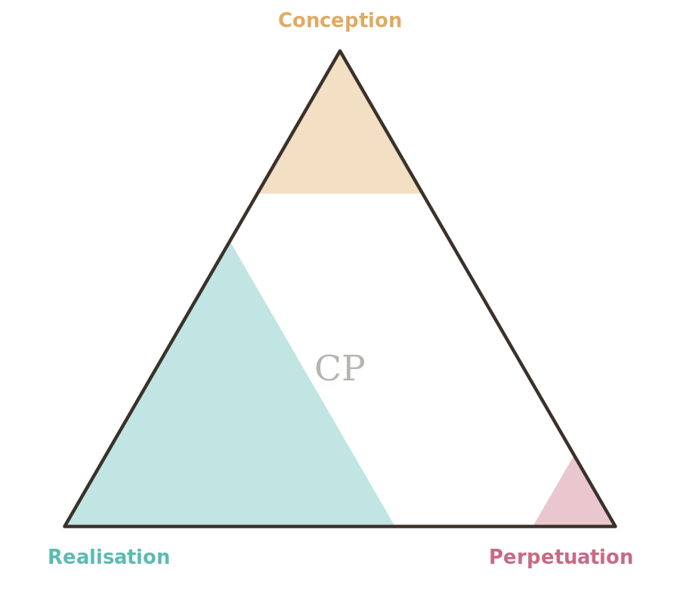

CProvenance — Quick-Start Guide
Score any work in five minutes

What CProvenance tells you

Conception  Think | Realisation  Make | Perpetuation  Tend
The idea, the research, the decision to proceed, and the design. | Gathering resources, building it, checking it works, and releasing it. | Caring for it after release, adapting it over time, and retiring it.

Score it in four steps
- Take each part in turn. For Conception, Realisation, then Perpetuation, list what actually happened.
- Estimate the AI share. For each activity, what proportion of the meaningful work did AI do or substantively direct? Ignore passive tools — spell-checkers and calculators don’t count.
- Weight by importance. Give more weight to the activities that mattered most to that part.
- Round to the nearest 5%. Write the three numbers as CP(C/R/P), and record today’s date. Honest estimate beats false precision.

Banding guide
Use these bands as anchors for each part.

Band | Conception | Realisation | Perpetuation
None (0%) | Idea, research, judgement and design wholly human. | Built, tested and released entirely by human hands. | Stewardship, support and iteration entirely human — or not yet begun.
Light (1–25%) | AI used lightly — a brainstorming prompt or quick scan — but direction stays human. | AI used as a minor aid (a small draft, a quick check); the making is human. | Minor AI assistance in support or monitoring; humans steward the work.
Moderate (26–50%) | AI meaningfully contributed to research or options; humans made the key decisions. | AI produced a meaningful share of the output, substantially reworked by humans. | AI handles a meaningful part of monitoring, support or iteration alongside humans.
Substantial (51–75%) | AI generated much of the concept, framing or structure; humans curated and steered. | AI generated most of the output; humans reviewed, edited and assembled. | AI runs most ongoing stewardship and adaptation; humans oversee.
Predominant (76–100%) | Concept, framing, research and design originated predominantly from AI. | The artefact was produced predominantly by AI, with light human involvement. | The work is sustained and evolved predominantly by AI.

Five worked examples
Work | Score | Why
Journalism | CP(15/35/5) | Human lead and writing; AI analysed leaked documents; human editor.
Visual art (generative) | CP(60/75/0) | AI shaped direction and produced the image; the artist curated and finished it.
Software | CP(15/65/30) | Human architecture; ~70% AI-generated code, human-reviewed; AI-assisted monitoring.
Academic paper | CP(5/40/0) | Human study and data; AI ran analysis and drafted sections, heavily rewritten.
Restaurant dish | CP(55/5/0) | AI proposed the concept and pairings; the chef developed and cooked it.

Publish the result
Pair the score with the mark and place it where provenance is conventionally found — a colophon or footer, an about page or README, or file metadata. The toolkit generates the mark (SVG and PNG) and ready-to-paste JSON-LD and meta tags for you.
- Inline: CP(15/60/5) · scored under CProvenance v0.2
- Visible mark: labelled mark at ≥30 mm (full colour) or ≥15 mm (mono); the bare stamp from 8 mm; below 8 mm, metadata only.
- Machine-readable: JSON-LD or meta tags in the page head; XMP for images.

Open the toolkit (website/index.html) to rate a work, generate a badge, or decode a score.
Provenance: CP(35/75/5) · scored 7 July 2026 under CProvenance v0.2 — human-directed concept, structure and editing; AI-assisted research and drafting; human-led stewardship with AI assistance.

